LAB 3: Stationarity Analysis Using ADF & KPSS Tests

Code:
import pandas as pd
import numpy as np
import matplotlib.pyplot as plt
from statsmodels.tsa.stattools import adfuller, kpss

# Load cleaned data
df_Anish = pd.read_csv('cleaned_timeseries.csv', index_col='date', parse_dates=True)

print("="*60)
print("LAB 3: STATIONARITY TESTING")
print("="*60)

# Q1: Rolling Mean and Rolling Standard Deviation
print("\nQ1. Rolling Statistics")
print("="*60)

# Calculate rolling statistics
window = 30 # 30-day window
rolling_mean = df_Anish['value'].rolling(window=window).mean()
rolling_std = df_Anish['value'].rolling(window=window).std()

# Plot
fig, ax = plt.subplots(figsize=(14, 7))
ax.plot(df_Anish.index, df_Anish['value'], color='steelblue', label='Original', linewidth=1)
ax.plot(rolling_mean.index, rolling_mean, color='red',
label=f'Rolling Mean ({window}-day)', linewidth=2)
ax.plot(rolling_std.index, rolling_std, color='green',
label=f'Rolling Std ({window}-day)', linewidth=2)
ax.set_xlabel('Date', fontsize=12)
ax.set_ylabel('Value', fontsize=12)
ax.set_title('Rolling Mean and Standard Deviation', fontsize=14, fontweight='bold')
ax.legend(loc='best')
ax.grid(True, alpha=0.3)
plt.tight_layout()
plt.savefig('lab3_rolling_stats.png', dpi=300, bbox_inches='tight')
plt.show()

print("\nQ1a. Comment on Stationarity:")
print("The plot indicates NON-STATIONARITY because:")
print("- Rolling mean shows an upward trend (not constant)")
print("- Rolling standard deviation shows variations over time")
print("- For a stationary series, both should remain relatively constant")

# Q2: Augmented Dickey-Fuller (ADF) Test
print("\n" + "="*60)
print("Q2. Augmented Dickey-Fuller (ADF) Test")
print("="*60)

ADF_result = adfuller(df_Anish['value'].dropna(), autolag='AIC')

print(f"ADF Statistic: {ADF_result[0]:.6f}")
print(f"p-value: {ADF_result[1]:.6f}")
print(f"Number of lags used: {ADF_result[2]}")
print(f"Number of observations: {ADF_result[3]}")
print("\nCritical Values:")
for key, value in ADF_result[4].items():
print(f" {key}: {value:.4f}")

print("\nInference:")
if ADF_result[1] <= 0.05:
print("p-value ≤ 0.05: REJECT null hypothesis")
print("The series is STATIONARY (according to ADF)")
else:
print("p-value > 0.05: FAIL TO REJECT null hypothesis")
print("The series is NON-STATIONARY (according to ADF)")

# Q3: KPSS Test
print("\n" + "="*60)
print("Q3. Kwiatkowski-Phillips-Schmidt-Shin (KPSS) Test")
print("="*60)

kpss_result = kpss(df_Anish['value'].dropna(), regression='c', nlags='auto')

print(f"KPSS Statistic: {kpss_result[0]:.6f}")
print(f"p-value: {kpss_result[1]:.6f}")
print(f"Number of lags used: {kpss_result[2]}")
print("\nCritical Values:")
for key, value in kpss_result[3].items():
print(f" {key}: {value:.4f}")

print("\nInference:")
if kpss_result[1] <= 0.05:
print("p-value ≤ 0.05: REJECT null hypothesis")
print("The series is NON-STATIONARY (according to KPSS)")
else:
print("p-value > 0.05: FAIL TO REJECT null hypothesis")
print("The series is STATIONARY (according to KPSS)")

# Q4: Conclusion and Explanation
print("\n" + "="*60)
print("Q4. Final Conclusion and Importance of Both Tests")
print("="*60)

# Create summary table
summary = pd.DataFrame({
'Test': ['ADF', 'KPSS'],
'Null Hypothesis': ['Non-stationary', 'Stationary'],
'p-value': [ADF_result[1], kpss_result[1]],
'Result': [
'Stationary' if ADF_result[1] <= 0.05 else 'Non-stationary',
'Stationary' if kpss_result[1] > 0.05 else 'Non-stationary'
]
})

print("\nTest Summary:")
print(summary.to_string(index=False))

# Determine final conclusion
ADF_stationary = ADF_result[1] <= 0.05
kpss_stationary = kpss_result[1] > 0.05

print("\nFinal Conclusion:")
if ADF_stationary and kpss_stationary:
print("STATIONARY: Both tests confirm stationarity")
elif not ADF_stationary and not kpss_stationary:
print("NON-STATIONARY: Both tests confirm non-stationarity")
else:
print("INCONCLUSIVE: Tests give conflicting results (difference stationary)")

print("\n" + "-"*60)
print("Why Check Both ADF & KPSS?")
print("-"*60)
print("\n1. COMPLEMENTARY HYPOTHESES:")
print(" - ADF: Null = Non-stationary (looks for unit root)")
print(" - KPSS: Null = Stationary (looks for trend/level stationarity)")
print(" Testing both provides stronger evidence.")

print("\n2. DIFFERENT TYPES OF NON-STATIONARITY:")
print(" - ADF detects: Unit root non-stationarity")
print(" - KPSS detects: Trend or level non-stationarity")
print(" Using both helps identify the specific type.")

print("\n3. CONFIRMATORY ANALYSIS:")
print(" - If both agree → Strong conclusion")
print(" - If they differ → Suggests difference-stationary series")
print(" (stationary after differencing)")

print("\n4. AVOIDING TYPE I & II ERRORS:")
print(" - Using only one test risks false conclusions")
print(" - Both tests reduce risk of incorrect inference")

# Create visualization of decision matrix
print("\n" + "-"*60)
print("Decision Matrix:")
print("-"*60)
print("┌─────────────────┬──────────────┬──────────────────┐")
print("│ ADF Result │ KPSS Result │ Conclusion │")
print("├─────────────────┼──────────────┼──────────────────┤")
print("│ Stationary │ Stationary │ Stationary │")
print("│ Non-stationary │ Non-stat. │ Non-stationary │")
print("│ Stationary │ Non-stat. │ Trend-stationary │")
print("│ Non-stationary │ Stationary │ Difference-stat. │")
print("└─────────────────┴──────────────┴──────────────────┘")

print("\n" + "="*60)
print("LAB 3 COMPLETED")
print("="*60)

Output:
============================================================
LAB 3: STATIONARITY TESTING
============================================================

Q1. Rolling Statistics
============================================================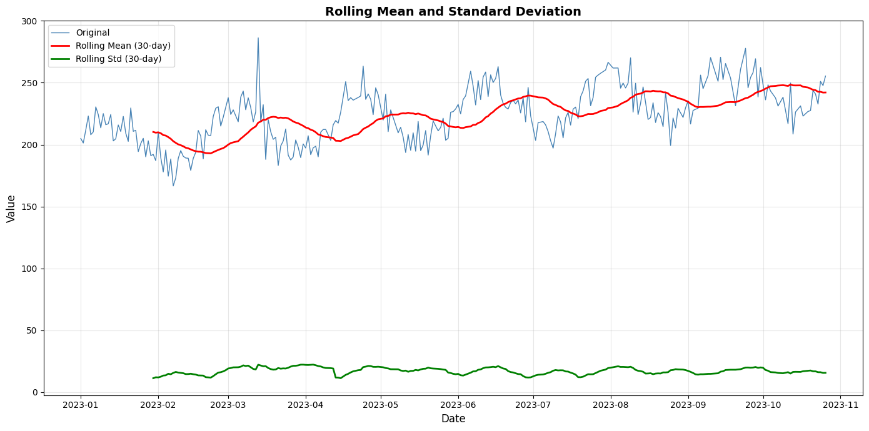
Q1a. Comment on Stationarity:
The plot indicates NON-STATIONARITY because:
- Rolling mean shows an upward trend (not constant)
- Rolling standard deviation shows variations over time
- For a stationary series, both should remain relatively constant

============================================================
Q2. Augmented Dickey-Fuller (ADF) Test
============================================================
ADF Statistic: -3.123539
p-value: 0.024860
Number of lags used: 8
Number of observations: 263

Critical Values:
1%: -3.4555
5%: -2.8726
10%: -2.5727

Inference:
p-value ≤ 0.05: REJECT null hypothesis
The series is STATIONARY (according to ADF)

============================================================
Q3. Kwiatkowski-Phillips-Schmidt-Shin (KPSS) Test
============================================================
KPSS Statistic: 1.233233
p-value: 0.010000
Number of lags used: 10

Critical Values:
10%: 0.3470
5%: 0.4630
2.5%: 0.5740
1%: 0.7390

Inference:
p-value ≤ 0.05: REJECT null hypothesis
The series is NON-STATIONARY (according to KPSS)

============================================================
Q4. Final Conclusion and Importance of Both Tests
============================================================

Test Summary:
Test Null Hypothesis p-value Result
ADF Non-stationary 0.02486 Stationary
KPSS Stationary 0.01000 Non-stationary

Final Conclusion:
INCONCLUSIVE: Tests give conflicting results (difference stationary)
------------------------------------------------------------
Why Check Both ADF & KPSS?
------------------------------------------------------------
1. COMPLEMENTARY HYPOTHESES:
- ADF: Null = Non-stationary (looks for unit root)
- KPSS: Null = Stationary (looks for trend/level stationarity)
Testing both provides stronger evidence.

2. DIFFERENT TYPES OF NON-STATIONARITY:
- ADF detects: Unit root non-stationarity
- KPSS detects: Trend or level non-stationarity
Using both helps identify the specific type.

3. CONFIRMATORY ANALYSIS:
- If both agree → Strong conclusion
- If they differ → Suggests difference-stationary series
(stationary after differencing)

4. AVOIDING TYPE I & II ERRORS:
- Using only one test risks false conclusions
- Both tests reduce risk of incorrect inference
------------------------------------------------------------
Decision Matrix:
------------------------------------------------------------
┌─────────────────┬──────────────┬──────────────────┐
│ ADF Result │ KPSS Result │ Conclusion │
├─────────────────┼──────────────┼──────────────────┤
│ Stationary │ Stationary │ Stationary │
│ Non-stationary │ Non-stat. │ Non-stationary │
│ Stationary │ Non-stat. │ Trend-stationary │
│ Non-stationary │ Stationary │ Difference-stat. │
└─────────────────┴──────────────┴──────────────────┘

============================================================
LAB 3 COMPLETED
============================================================

